**Systems Design**

**Automation of Initech ITAM Process**

Swetha Anantha Murthy

Sushmitha Alagesan

Likhith Sri Vatsa Uppada

Divya Parameswaran

Prof. Dr. Tatiana Walsh

April 10, 2022

Table of Contents

Background 4

Problem Statement 4

Technology Solution 4

Process Maps 4

Functions and Requirements Table 8

User Interface 10

Wireframe 1: Desktop based GUI for Asset Management System (Security Process) 10

Description 10

Wireframe 2: Asset Tracking Dashboard 16

Description 16

Wireframe 3: Stockroom Management 17

Description 17

Wireframe 4: ITAM Process - Asset Entry 19

Description 19

Wireframe 5: ITAM Process - Asset Request 20

Description 20

Wireframe 6: ITAM Process – Asset Fulfillment Request 21

Description 21

Wireframe 7: ITAM Process – Support 22

Description 22

Wireframe 8: ITAM Process – Asset Retirement 23

Description 23

Wireframe 9: ITAM Process Dashboard 24

Description 24

Infrastructure Architecture 25

Network Topology 25

Entity Relationship Diagram 27

Security and Privacy Architecture 29

Programming 31

Table of Figures

Figure 1: Serialized asset tracking 4

Figure 2: Stockroom management process 5

Figure 3: ITAM Process 6

Figure 4 : Security Process 7

Figure 5: User Registration_1 11

Figure 6: User Registration_2 12

Figure 7: Login Page 13

Figure 8: Two Factor Authentication 14

Figure 9: Home Page 15

Figure 10: Asset Tracking Dashboard 16

Figure 11: Stockroom entry user interface 18

Figure 12: Asset entry user interface 19

Figure 13: Asset Request user interface 20

Figure 14: Asset Fulfillment user interface 21

Figure 15: Support Process user interface 22

Figure 16: Retirement process user interface 23

Figure 17: ITAM Dashboard 24

Figure 18: Network Topology 25

Figure 19: Entity Relationship Diagram 27

# Background

(Sushmitha Alagesan)

## Problem Statement

  According to the recent audit report, IniTech Solutions is experiencing a problem with the present techniques for managing asset data which includes data duplication and mismanagement, visualization issues, and decentralized data models.

## Technology Solution

Our technology solution to address various issues that are identified in the recent audit report is to create an in-house IT asset management system.

## Process Maps

**Serialized asset tracking**

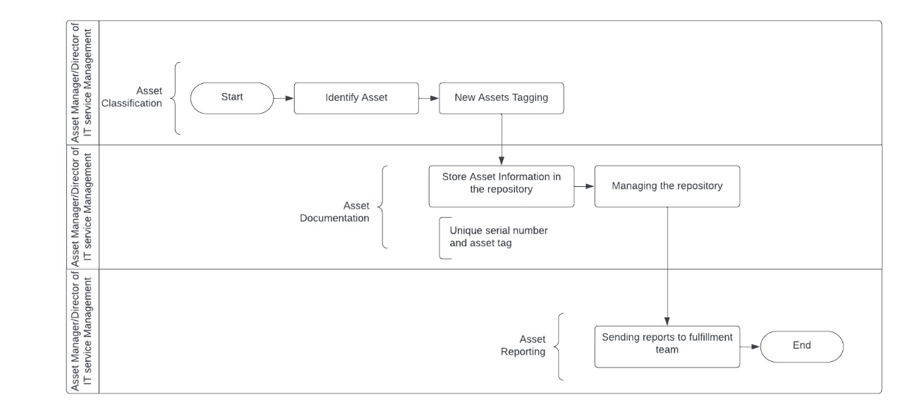

**Figure 1: Serialized asset tracking**

**Stockroom Management**



**Figure 2: Stockroom management process**

**ITAM Process**

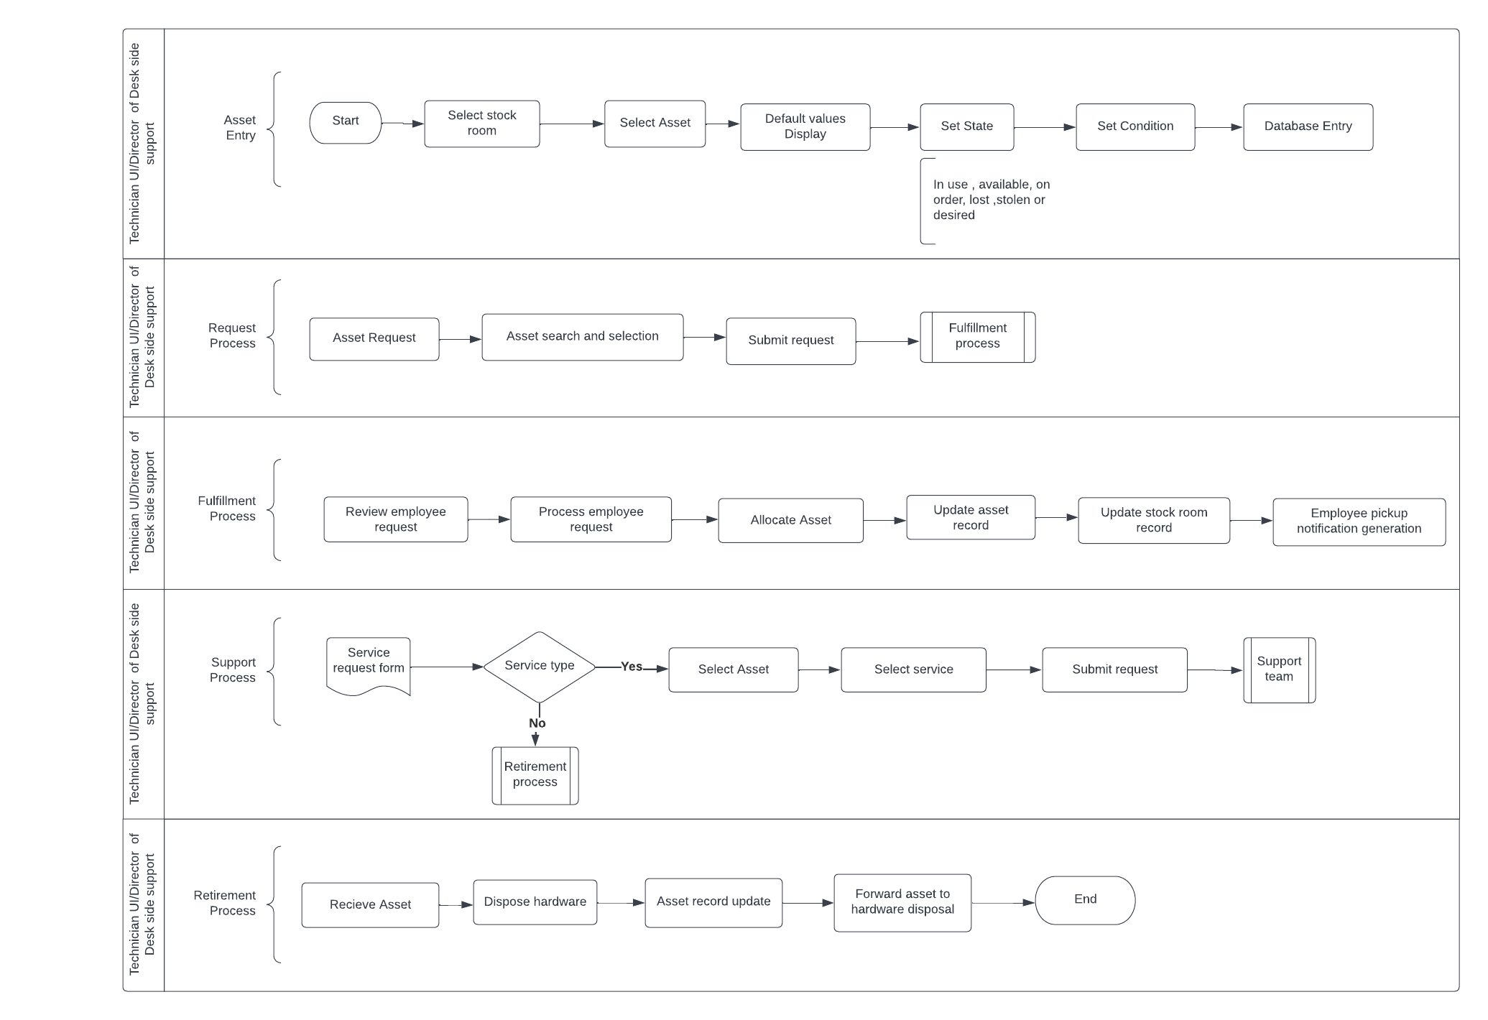

**Figure 3: ITAM Process**

**Security Process**

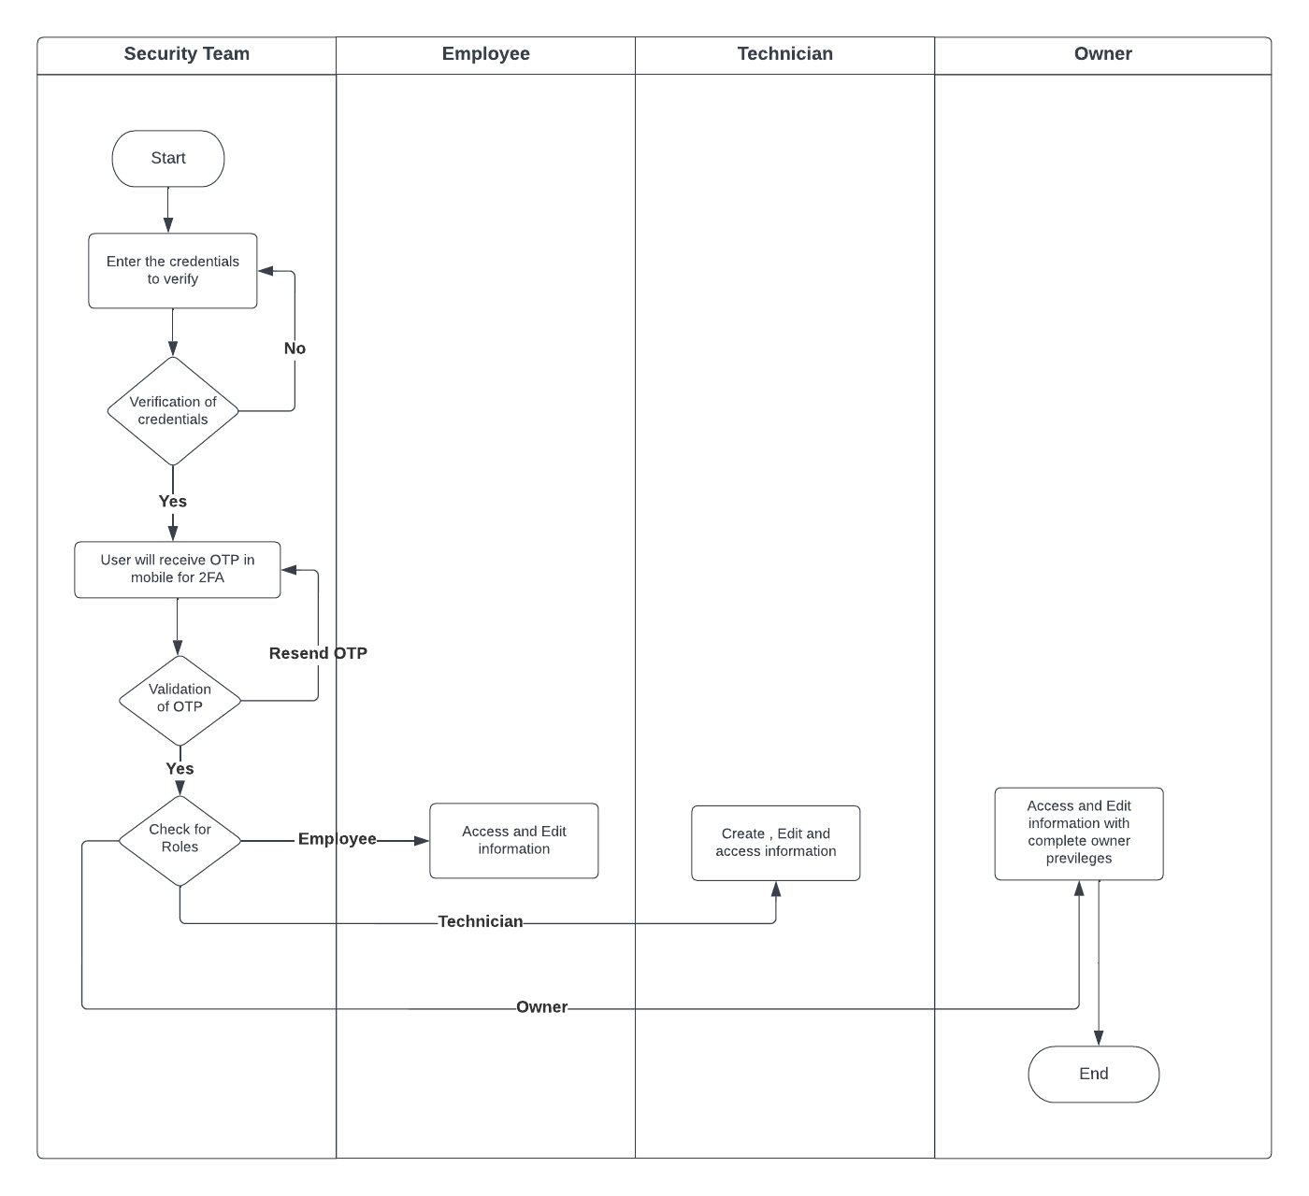

**Figure 4 : Security Process**

## Functions and Requirements Table

|  |  |
| --- | --- |
| **FUNCTION** | **REQUIREMENTS** |
| **Serialized asset tracking**  Tracking key information such as asset maintenance, scheduling, expiration, and recycling is achieved with the computerized asset management system.  The businesses will gain complete asset visibility including location, status, and usage history, using a single web-based dashboard that enables for quick search and tag filtering. | * + Asset identification involves asset manager to be able to classify the assets based on its features.   + Each asset has a unique identifier.   + The asset data gets updated during each stage.   + The asset information’s are maintained in the repository.   + Asset details reporting to the fulfillment team.   + The users will get to choose between the available assets. |
| **Stockroom management**  Stockroom management will assist our company in knowing exactly where its products are, maintaining an accurate count of all items, and ensuring room for new orders.  A well-organized warehouse improves the efficiency of present and future  fulfillment strategies. This includes cost savings and improved product quality for companies  that employ warehouses to manage inventories. | * + Assign a unique identifier, a series of 5 characters alphanumeric to each stockroom.   + Define buildings with a unique combination key to select any building to assign.   + Enter the room number along with the address.   + Users can access the stock room using a physical lock or an access card that will be indexed.   + Each stockroom should have a stockroom manager assigned to them.   + Assign a stockroom manager contact information to each stockroom.   + Stockroom requires preparation of standardized security control options. |
| **ITAM Process**  The request and fulfillment process is a management procedure that touches every other  function since it requires data updates in the central repository once the request is reviewed by another team. The functions are:   1. Asset entry 2. Request process 3. Fulfillment process 4. Support process 5. Retirement process | * + The system will have to enable the technician to enter the database details.   + The default data should come with barcode information.   + The system enables the technician UI to update the database with asset state and conditions.   + The employee UI must enable employee to make asset request to the IT service management.   + The IT service management must comply security protocols and grant service request access to the employee for request fulfillment.   + The request fulfilment process should follow the asset state and condition update at the beginning and end of the request.   + Retirement of an asset is done by the technician.   + The system provides the user to track the asset request raised. |
| **Security process**  The goal of security management is to maintain high-level security to every function and  separate the access of function to various roles based on the stakeholder level of authority.  This is done to ensure that the underlying sensitive data is kept as secure as possible. | * + A single sign-on with a two-factor authentication solution is required for the system being created.   + Employees should possess mobile devices to authenticate two-factor authentication.   + Grouping for role-based access, and controls, with the focus on the principle of least privilege.   + Auto-recommendation system for the level of access required by each role in the system. |

# User Interface

(Swetha Anantha Murthy)

## Wireframe 1: Desktop based GUI for Asset Management System (Security Process)

### Description

First and foremost, when a client or an Initech employee attempts to log in to the company's website, they must choose their logging in option via the user login page. Then, for a safe and secure log in, a login page with two factor authentication is developed. To use Initech Solutions' services, every user must first create an account on InitechSolutions.com. Employees of Initech will be registered for the same. Following the completion of the registration process, the user will be directed to the login page. And upon successful login with user id and password, the user will be directed to the authentication page, where they will receive a unique code or OTP on their mobile phones, which must be entered on the authentication page. Then the user will be able to visit the homepage of Initech Solutions after the successful logging in. From the home page, the user can navigate to the required sections (asset tracking, stockroom management, ITAM process, security).

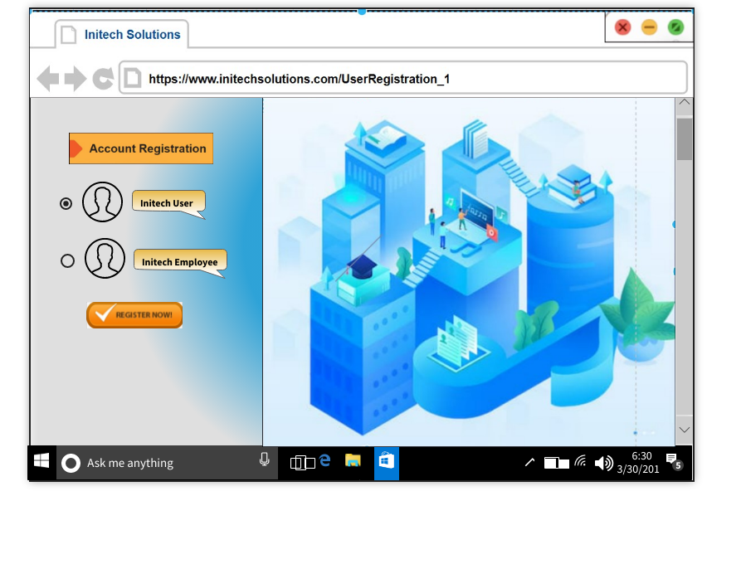

**Figure 5: User Registration_1**

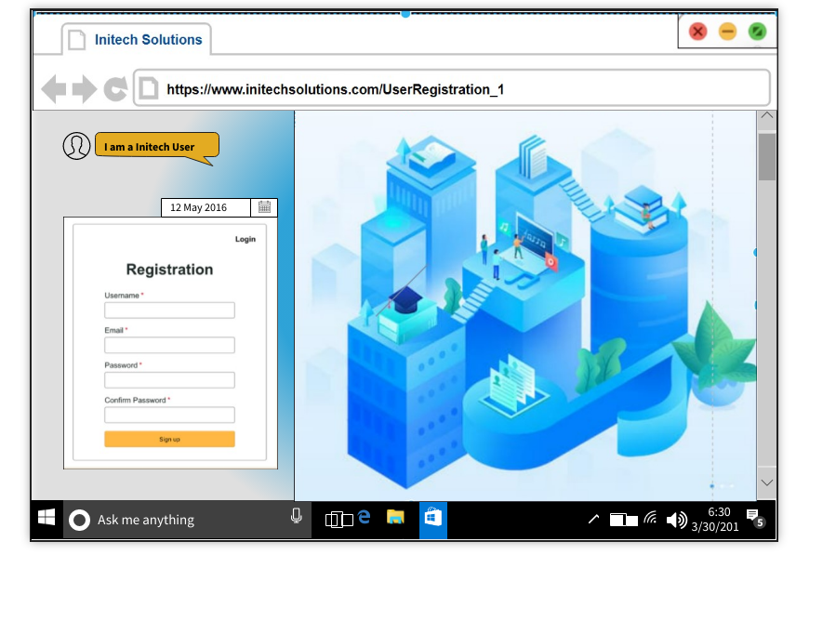

**Figure 6: User Registration_2**

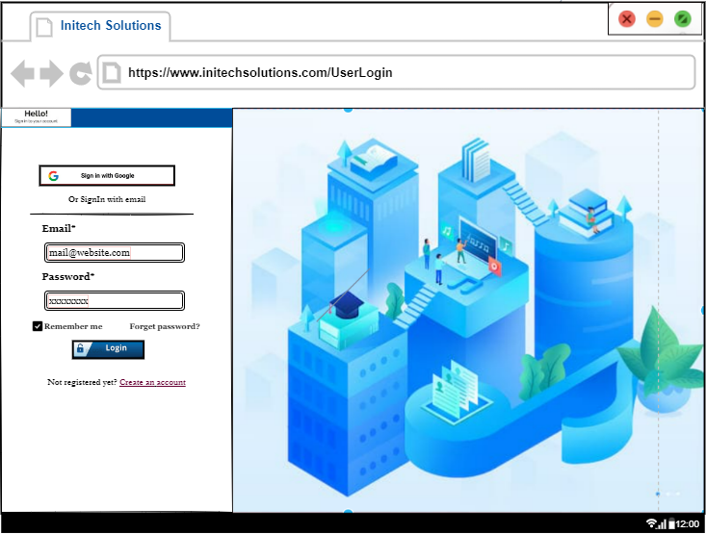

**Figure 7: Login Page**

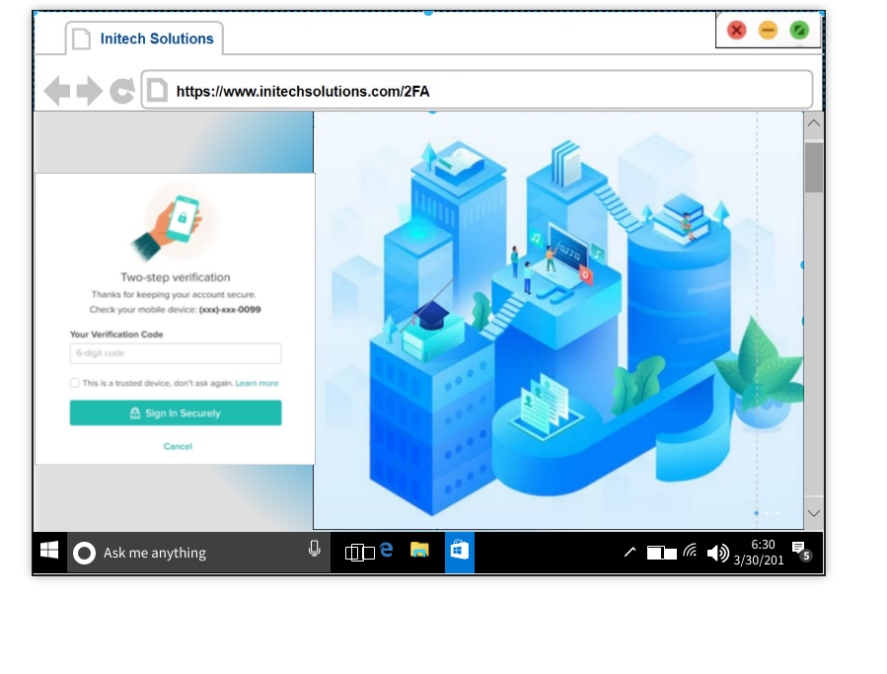

**Figure 8: Two Factor Authentication**

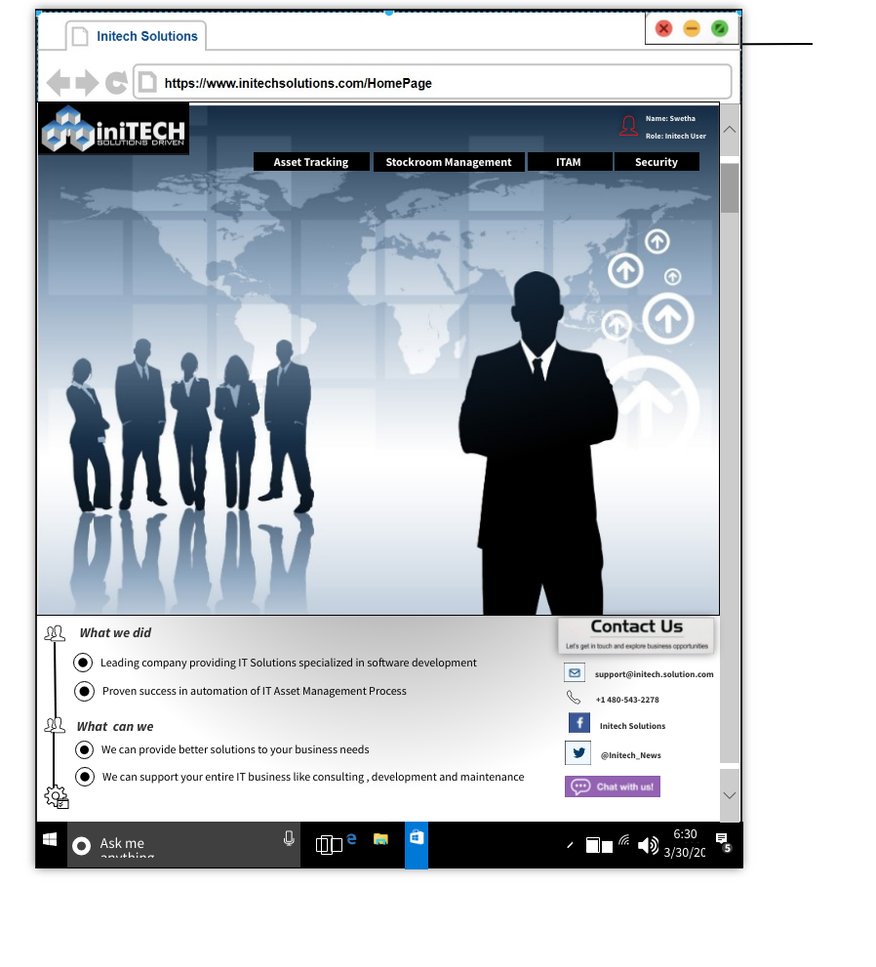

**Figure 9: Home Page**

## Wireframe 2: Asset Tracking Dashboard

### Description

The asset tracking dashboard is a visual representation of the overall information in the serialized asset tracking process. The quantity of assets reflects the entire number of assets accessible for usage, whereas the purchase in the fiscal year shows the total amount spent on the asset in that year. The asset value for each day has been charted. In addition to this, the dashboard features feed sections that include the asset tag id and the asset's due date.

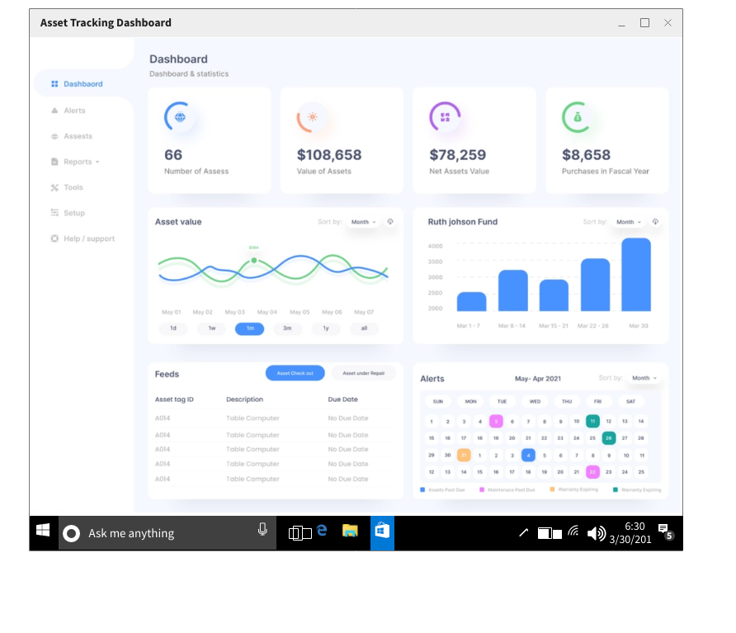

**Figure 10: Asset Tracking Dashboard**

## Wireframe 3: Stockroom Management

### Description

The stock room management webpage has been designed to assist the user to gain access to the stockrooms. Each stockroom is assigned with unique identifiers. To have the access approved, users have to provide inputs such as unique identifier details, room number, building number, address, and the security control options in the webpage. The security control options will be validated and if the physical key matches, the access will be approved. Once the access is approved, the user can be able to access the stockroom. On the other hand, the access will be refused if the unique identifier information is inaccurate, or the physical key is not matched. In that case, the user has to contact the stockroom manager responsible for that particular stockroom in order to gain access.

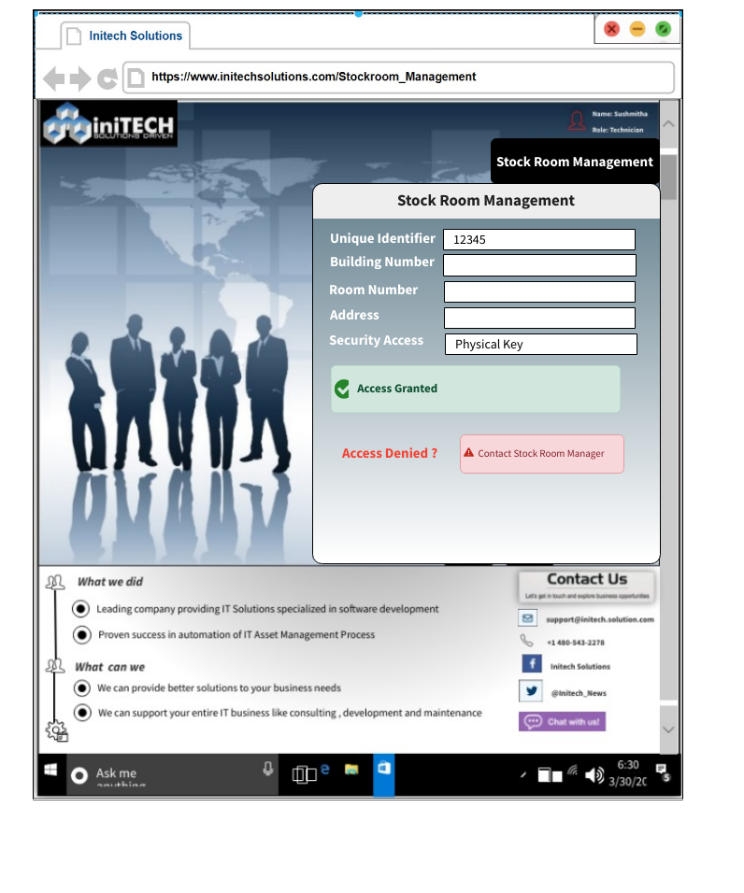

**Figure 11: Stockroom entry user interface**

## Wireframe 4: ITAM Process - Asset Entry

### Description

All five processes in the ITAM process – asset entry, asset request, fulfillment process, support process, and asset retirement process have their own user interface. The asset entry user interface is used to enter asset data into the repository. The user must provide inputs such as the asset id, asset name, asset model, asset location, and the details of the person to whom the asset is assigned. After providing all the required information, the user must select the update repository option to save the asset information to the repository, and this process should be repeated whenever the asset status or asset condition changes.

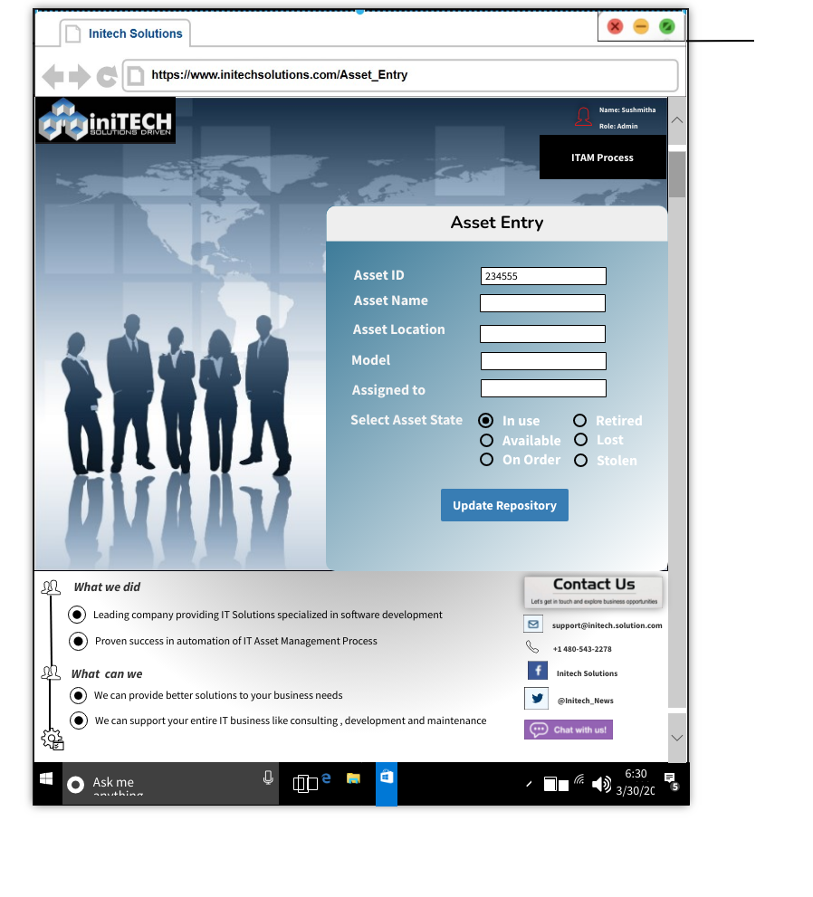

**Figure 12: Asset entry user interface**

## Wireframe 5: ITAM Process - Asset Request

### Description

Employees will be able to submit a request to install equipment from a stock room via the request process. They can utilize the asset request user interface for this purpose. The employee must provide input data such as employee id, employee name, project name, and preferred asset type (for example HP in our case). The details will be retrieved from the repository that matches the employee’s selection criteria, and a message will be displayed indicating whether he can proceed with the request. Then the user can proceed to submit the new request by clicking the submit request button. These access requests will be handled by the fulfillment team.

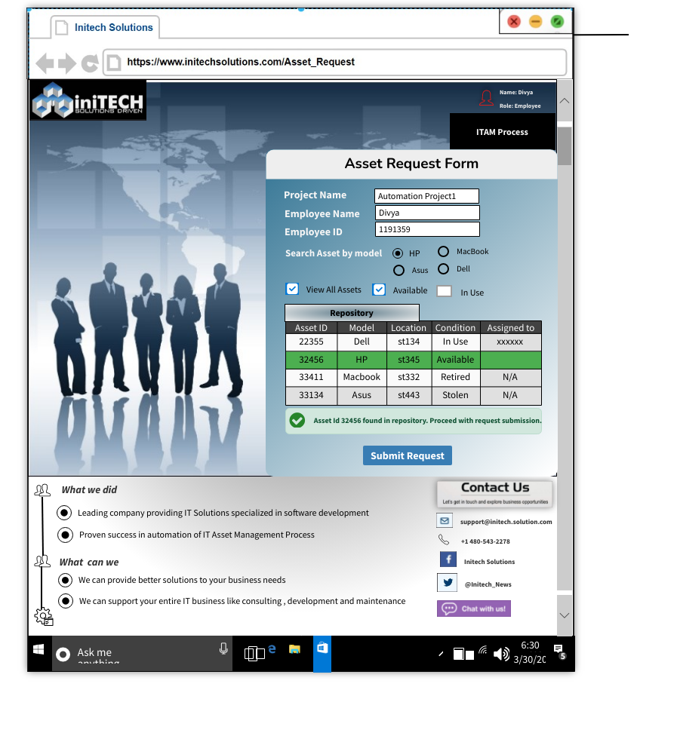

**Figure 13: Asset Request user interface**

## Wireframe 6: ITAM Process – Asset Fulfillment Request

### Description

The technicians will be able to handle the asset request via the asset fulfillment user interface. This user interface will display the overall number of tickets (requests) to handle, as well as the open, pending, on hold, and closed requests. The technician can view the request details by clicking on the request number, and he also has the authority to verify the asset status prior to processing the request. If the request fails to pass the asset status validation check, the user interface provides the option to deny the request.

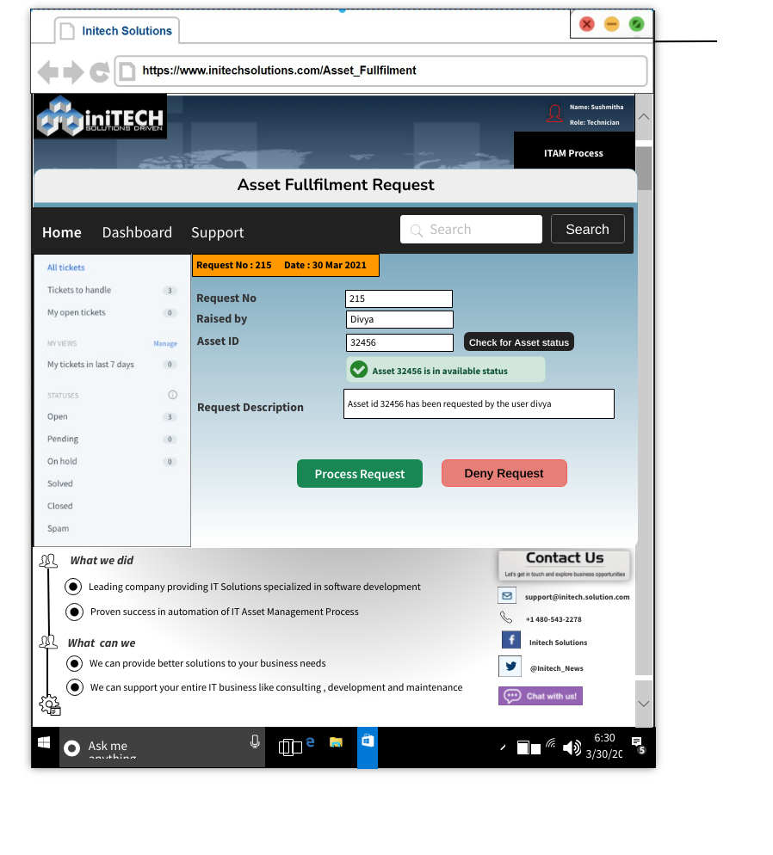

**Figure 14: Asset Fulfillment user interface**

## Wireframe 7: ITAM Process – Support

### Description

The employee can submit the service requests for the support services like installation of software, replacement of hard drives or system refresh, through the user interface built for the support process. In the support user interface, the user must enter the employee id, asset id, and phone number as an input, and select asset status and issue/services from the dropdown menu. The user interface additionally includes a text area for describing the issue (add note section).

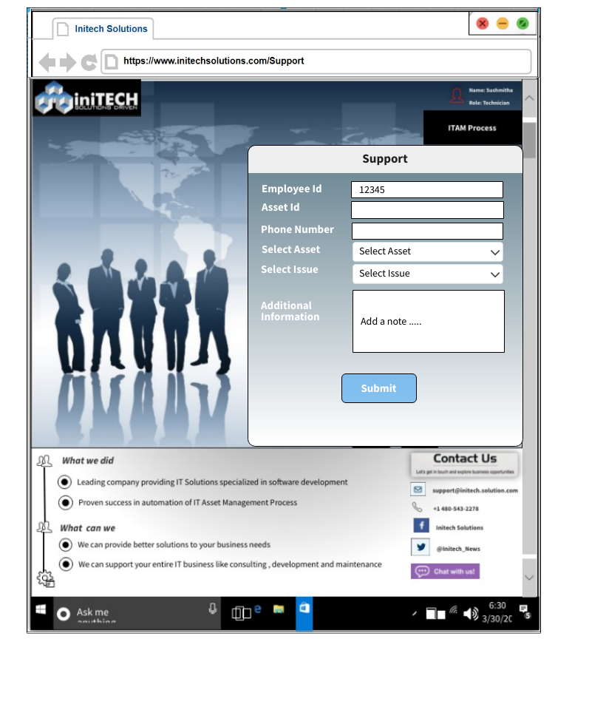

**Figure 15: Support Process user interface**

## Wireframe 8: ITAM Process – Asset Retirement

### Description

The asset retirement user interface assists the technician in the asset disposal maintenance When submitting the request, the user must include information such as the asset identification number, location of the asset, model name, asset owner data, asset status (disposal, retired, lost, damaged, or stolen), and asset submission date. Upon submitting the details, a notification is sent to the delivery team for asset collection along with the asset status and the details are updated in the repository.

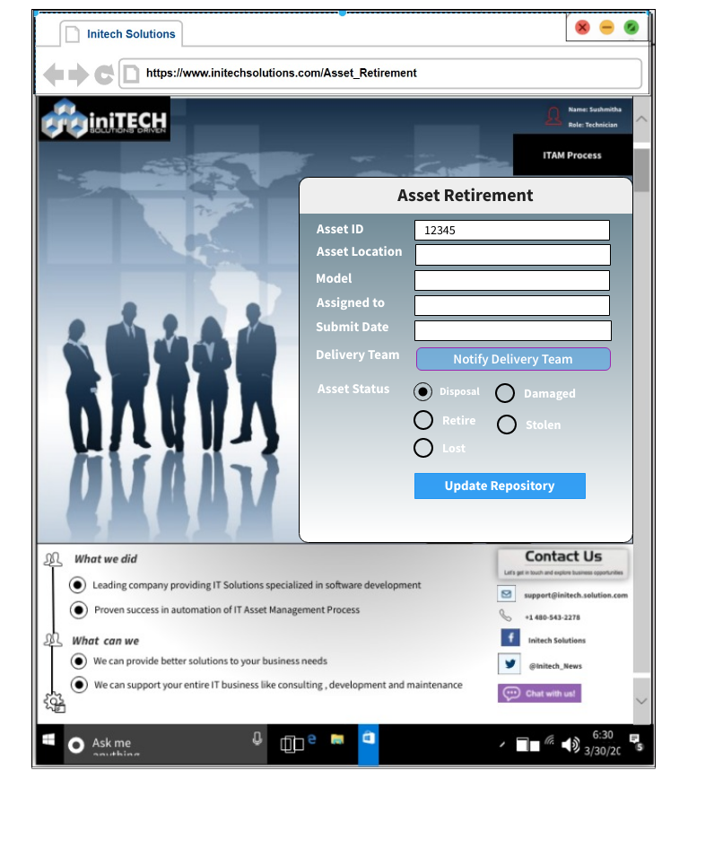

**Figure 16: Retirement process user interface**

## Wireframe 9: ITAM Process Dashboard

### Description

The various phases of ITAM process has been displayed in a single dashboard. The asset entry pie chart depicts the total volume of asset types such as desktop, laptops, monitors and servers. The asset request pie chart depicts the status and number of requests from different categories. In addition to that, the dashboard includes the week-wise fulfillment status in the form of graph. The numbers of retired assets for the years 2020 and 2021 can also be viewed, along with the number of support request resolved.

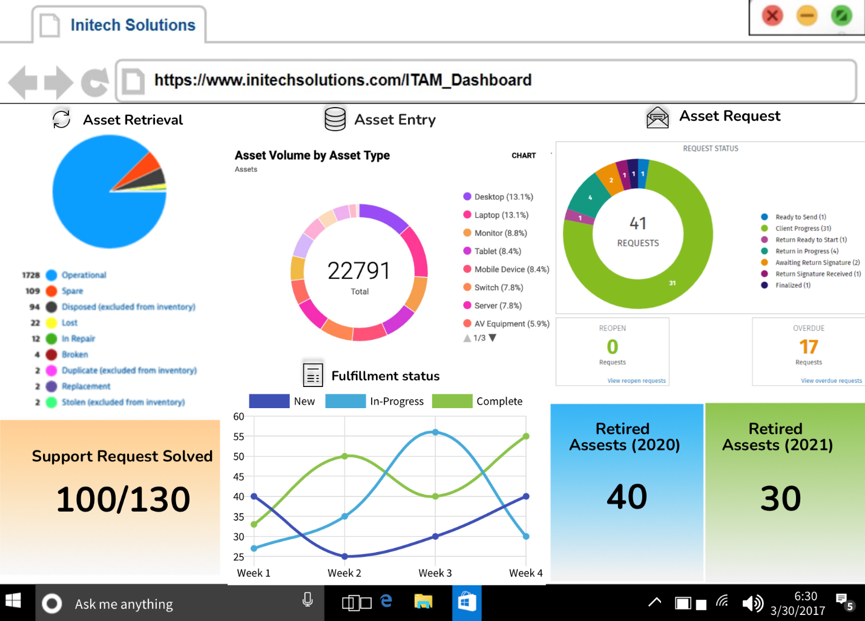

**Figure 17: ITAM Dashboard**

# Infrastructure Architecture

(Divya Parameswaran)

## Network Topology

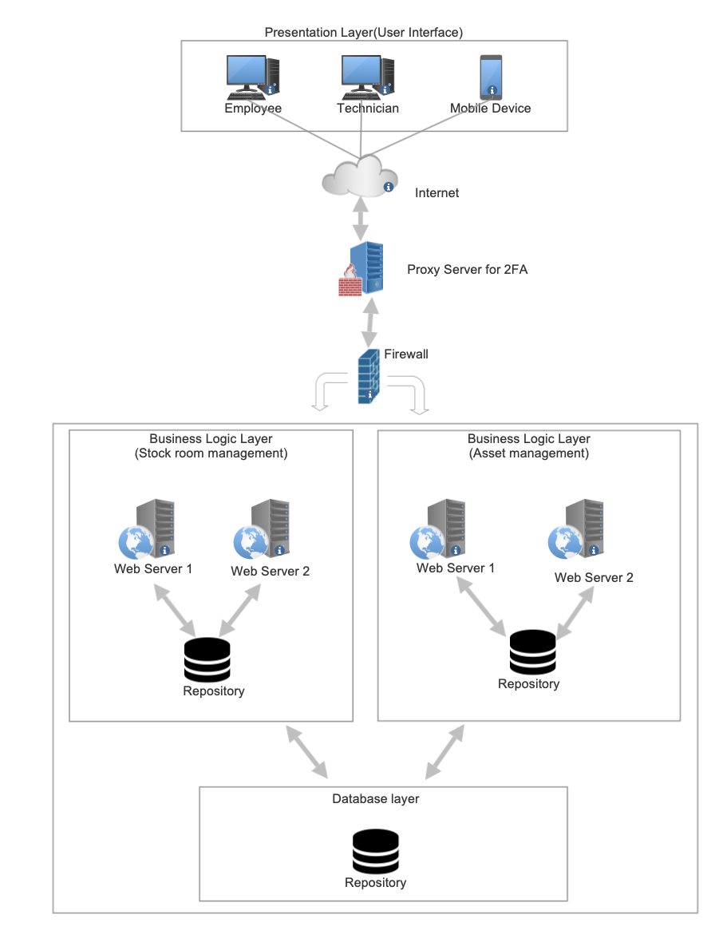

**Figure 18: Network Topology**

**Description**

The network topology of the Initech system is divided into three layers: presentation layer, business layer, and database layer. The presentation layer ensures that the communications it receives are formatted appropriately for the recipient application. In addition, the presentation layer serves as the user's and workers' first point of contact when they use the online application. It consists of desktop computers, laptop computers, and mobile devices that customers utilize to access the application.

The proxy server is then used to perform two-factor authentication when a user or employee attempts to access the system. The proxy server acts as a firewall, preventing the attacker from gaining access to the private network. Any data entered by the user via the user interface must pass through the firewall to reach the business and database layers. This is because, the firewall act as the network security device that monitors and filters inbound and outbound network traffic in accordance with an organization's security policies. The organization’s whole network is made secured with the help of firewall.

The data that successfully gets through the firewall will be routed to the business logic layer which contains web servers in it. The Business Logic Layer manages the business rules, calculations, and logic that determines how an application should function. Here we have two web servers for stockroom management and asset management where the actual process of stockroom inventory management and the serialized asset tracking process happens.

The database layer contains the repositories that encapsulate the logic required to access data sources. They centralize common data access functionality, providing better maintainability and decoupling the infrastructure or technology used to access databases from the domain model layer. Initech solutions has a centralized data repository where we can store the most up-to-date information on asset records, stockroom management data, and so on.

## Entity Relationship Diagram

(Likhith Sri Vatsa Uppada)

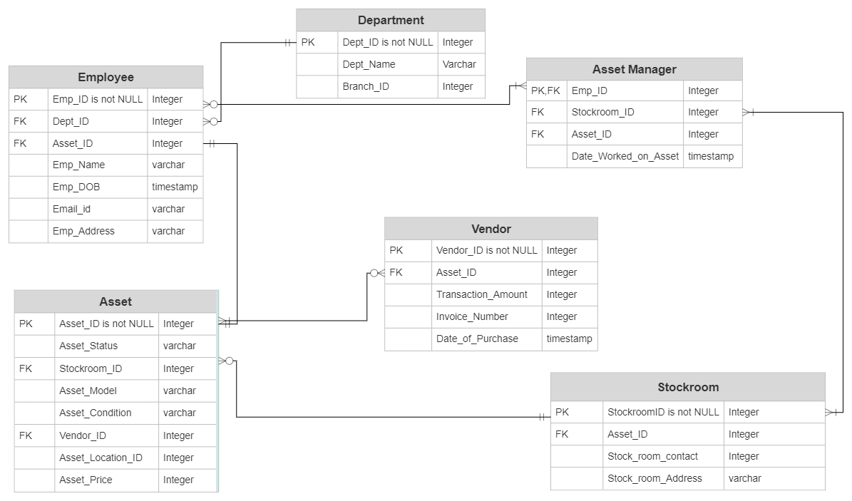

**Figure 19: Entity Relationship Diagram**

The ER Diagram has six entities:

* **Employee -** The employee table consists of various attributes that are associated with every employee who works for IniTech solutions. The attributes of employee table are Emp_ID, Dept_ID, Asset_ID, Emp_Name, Emp_DOB, Email_id, and Emp_Address. Here, Emp_ID acts as a primary key which has not NULL value. Dept_ID and Asset_ID acts as the foreign keys. Employee entity has one to many relationships with asset entity.
* **Department -** The department entity includes attributes like Dept_ID (name of the department) and the branch ID (branch name). Dept_ID acts as the primary key here, which has not NULL value. Department entity has one to many relationships with employee entity, because one department might have many employees in it.
* **Vendor –** The vendor entity includes attributes like Vendor_ID, Asset _ID, Transaction_Amount , Invoice_Number and Date_of _Purchase. Here, Vendor_ID acts as a primary key which has not NULL value and Asset_ID acts as a foreign key. The vendor entity has many to many relationship with asset entity.
* **Stockroom -** The stockroom entity includes attributes like StockroomID, Assset_ID, Stock_room_contact and Stock_room_Address. The StockroomID acts as the primary key and Asset_ID acts as the foreign key. The stock room entity has one to one relationship with asset manager.
* **Asset Manager –** The asset manager entity includes attributes like Emp_ID, Stockroom_ID, Asset_ID and Date_Worked_on_Asset. Here, the Emp_ID acts as primary key which has not NULL value and Asset_ID and Stockroom_ID acts as a foreign key. The asset manager entity has one to one relationship with stockroom, this is because one asset manager will be in charge for one stockroom.
* **Asset –** The asset entity includes the attributes like Asset_ID, Asset_Status, Stockroom_ID , Asset_Model , Asset_Condition , Vendor_ID , Asset_Location_ID and Asset_Price. Here, Asset_ID acts as the primary key which has not NULL value. Stockroom_ID and Vendor_ID acts as foreign key. The asset entity has many to one relationship with stockroom entity, because many assets can be placed in one stockroom.

# Security and Privacy Architecture

(Sushmitha Alagesan)

**Authentication**

* Authentication enables organizations to keep their networks secure by permitting only authenticated users or processes to gain access to their protected resources.
* The most common method of authentication is by using passwords. But passwords are insufficient for safeguarding the information, so nowadays many companies have strengthened authentication by requesting additional authentication elements, such as a unique code sent to a user via mobile device when a sign-on attempt is made in the system. This is called as “Two Factor Authentication”.
* The system will leverage software (such as Duo mobile) to implement a single sign-on solution with two-factor authentication.
* Single Sign On combines strategies to ensure that users do not have to enter their credentials more than once by sharing centralized authentication servers that all other applications and systems utilize for authentication.
* In addition, the Initech solution includes proxy servers that manage user authentication when they attempt to access the system. This will provide the application with an additional layer of security.

**Authorization**

* Authorization is the procedure through which a server determines if an individual has permission to use a resource or access a file.
* For authorization, the system needs role-based access, and control, with attention to the least privilege.
* Role-based access control allows declaring whether a user is an administrator, a technician user, or an employee so that one can match responsibilities and access permissions to workers' job titles. The system assigns privileges to the users based on the roles. For example, only the technician has access to process the asset requests during the fulfillment process in the Initech solutions system, whereas the employee just has permission to submit asset requests.
* Physical access control refers to a collection of policies that governs who has authorization or access to a certain physical location. In the stockroom management process, we have used physical access control, which allows employees to enter the stockrooms using a physical key or an access card.
* Risk control refers to a collection of procedures used by businesses to assess prospective losses and take steps to mitigate or eliminate them. For example, every company should have a backup strategy in place, with real-time business data being backed up constantly. This is because if an information system server fails, the company's activities will be disrupted, and this will result in data loss.  To mitigate this, the backup server should be ready right away if the primary server fails.

**Privacy**

* Access control regulations, such as software constraints, are implemented in the enterprise environment in order to maintain security and privacy in the asset management system.
* In the IT Asset Management system, only the Stock room administrator should be able to perform critical activities and manage the company's hardware. Appropriate detection and warning strategy is implemented for unauthorized access to enterprise assets or entities.
* Protection against attacks on system security and privacy is achieved by consistently scanning for potential vulnerabilities**.**

# Programming

(Divya Parameswaran)

We have done the sufficient research and identified the below recommendations for the development tools, programming languages, technologies, and COTS Platform.

**Recommended Development Tools**

* GitHub
* Docker
* Jira
* Jenkins
* Slack
* Trello
* Postman
* Confluence
* Fleed

**Recommended Technologies**

* Machine Learning
* Cloud Computing
* Big Data Analytics
* Virtual Reality
* Internet of Things (IoT)
* Artificial Intelligence
* Mobile Computing
* Cognitive Computing
* Blockchain
* PhpMy Admin

**Recommended COTS Platform**

* Microsoft Office
* Service Now
* Entellitrak
* Enterprise Resource Planning (ERP)
* CRM
* Websphere
* Azure data studio
* MongoDB

Advantages of using commercial off-the shelf technology solutions are as below:

* Helps to achieve integrity and consistency of data
* Helps to achieve improvement in data security
* Ability to store information for longer period
* Data entry, storage, retrieval costs are decreased.
* Using host and query languages, better handling of large volume of data can be achieved.

**Recommended Programming Language**

* Java
* C
* C++
* R
* Android
* Spring
* HTML
* CSS
* Javascript
* JQuery
* Python
* MySQL
* ReactJS

The development tools that we will use are as below:

* **GitHub:** It is a collaborative platform, as many developers collect data and publish it publicly, which can be beneficial to others. Developers at Initech Solutions can publish their code to github, and other developers can also access the same source code for the development purpose.
* **Git:** Initech Solutions encounters many updates while developing an application, so we need a version control system. Git is responsible for handling versions of code with speed and efficiency.
* **Jira:** Jira is an agile project management tool used to manage, track and plan software development project. The most significant aspect of the business is time management and reporting, which is handled by JIRA. In Initech solutions, the developers can log how long it takes them to complete a task by using JIRA, and other developers or testers can alter their dependencies accordingly. They can also change the status of their development from in-progress to completed, as well as whether the software has to be retested or not.
* **Jenkins**: It is a server-based system which runs on a servlet container Apache Tomcat. It helps to automate the parts of the software development related to testing, deploying, or building the software. In Initech solutions, Jenkins can be used to continuously integrate the code changes to the build.

The programming tools that we will use are as below:

* **Java:** This programming language is frequently used for backend software development since it is safe, portable, maintainable, and has more concurrency than any other language. The service and controller levels, which are coupled with the database layer, are the most important layers of any product, and the reason why these layers should be built in java is because of its concurrency and multithreading, which it handles very efficiently. In the Initech solution we can use java programming language to build the service layer and the controller layer, because this will help us to achieve the data concurrency in the system.
* **HTML & CSS:** The webpages (user interfaces) for Initech solutions can be created using a combination of hypertext markup language and CSS, which contains a number of tags that are easy to utilize in the creation of any website. It also supports cross-platform development, and it is very cost effective with offline browsing. In addition to this, it supports geolocation which is a primary feature to achieve safety and integrity factor.
* **MySQL:** MySQL provides security and ease of implementation of queries that make up the database. MySQL can run on any machine and is simple to integrate with backend languages such as Java. It aids in the reduction of data redundancy. For these reasons, we can use MySQL database to store the asset information and stockroom information efficiently in the repositories without any duplications.

**References**

Tilley, S. R. (2020). *Systems analysis and design*. Cengage.